Project - High Level Design

On
Healthcare Content Generator
  - Course Name: Datagami Skill based Course

Institution Name: Medicaps University – Datagami Skill Based Course

Student Name(s) & Enrolment Number(s):
Sr no | Student Name | Enrolment Number
01 | Ashlesha Verma | EN22CS301219
02 | Aryan Singh | EN22CS301215
03 | Avani Rawal | EN22CS301238
04 | Animesh Bokil | EN22CS301125
05 | Anshika Vyas | EN22CS301154

Group Name: Group10 D2
Project Number: GAI-22
Industry Mentor Name:
University Mentor Name: Dr. Hemlata Patel
Academic Year: 2026

Table Of Content
1. Introduction 3
1.1 Scope of the Document 3
1.2 Intended Audience 3
1.3 System Overview 3
2. System Design 4
2.1 Application Design 4
2.2 Process Flow 5
2.3 Information Flow 6
2.4 Components Design 7
2.5 Key Design Considerations 7
2.6 API Catalogue 8
3. Data Design 8
3.1 Data Model 8
3.2 Data Access Mechanism 10
3.3 Data Retention Policies 10
3.4 Data Migration 10
4. Interfaces 10
5. State and Session Management 10
6. Caching 11
7. Non-Functional Requirements 12
7.1 Security Aspects 12
7.2 Performance Aspects 12
8. References…………………………………………………………………………………………… 12

1.Introduction
MediScribe AI is a specialized Healthcare Content Generator web application designed to assist medical professionals in creating accurate, structured, and professional clinical documentation. In modern healthcare environments, doctors and clinicians often spend a significant amount of time manually drafting patient summaries, recording observations, and maintaining medical records. This documentation process, while essential, can be time-consuming and prone to inconsistencies in structure, terminology, and formatting.
MediScribe AI addresses this challenge by leveraging Generative AI through Large Language Models (LLMs) combined with a Vector Database using a Retrieval-Augmented Generation (RAG) architecture. The system accepts raw patient inputs such as symptoms, medical reports, and clinical findings, converts them into embeddings, stores them in a vector database, and retrieves relevant contextual data before generating a structured clinical summary. This ensures accuracy, contextual relevance, and professional medical tone.
Built using HTML and Tailwind CSS for the frontend and Python with Flask for the backend, the application is modular, scalable, and easy to extend. The architecture allows seamless replacement of LLM providers or vector databases, making it future-ready. MediScribe AI aims to improve efficiency, maintain documentation consistency, and support healthcare professionals in delivering better patient care through intelligent automation.

1.1 Scope of the Document
This document presents the High-Level Design (HLD) of the MediScribe AI Healthcare Content Generator web application. It outlines the overall system architecture, design principles, technology stack, workflow, and major functional components involved in the application. The document explains how raw patient data is processed, stored in a vector database, and utilized by a Large Language Model (LLM) to generate structured and professional clinical summaries.
The scope includes system modules, API definitions, data design, security considerations, performance aspects, and non-functional requirements. It also highlights the modular and scalable nature of the system, ensuring easy replacement of LLM providers or vector databases. This document serves as a technical blueprint for developers, mentors, and evaluators to understand the architecture and operational flow of the system.

1.2 Intended Audience
This document is intended for technical and academic stakeholders involved in the development, evaluation, and deployment of the MediScribe AI system. The primary audience includes software developers, AI/ML engineers, and system architects who require a clear understanding of the application’s architecture, workflow, and component-level design. It provides sufficient technical detail to guide implementation, maintenance, and future scalability.

The document is also designed for academic evaluators, university mentors, and industry mentors associated with the Datagami Skill Based Course at Medicaps University. It serves as a formal reference to assess the system’s design approach, technology choices, and adherence to modern AI architecture principles such as Retrieval-Augmented Generation (RAG).
Additionally, healthcare IT professionals and decision-makers may refer to this document to understand how Generative AI can be integrated into clinical documentation workflows. Overall, this document ensures that all stakeholders gain a comprehensive understanding of the system’s structure, objectives, and operational design.

1.3 System Overview
The MediScribe AI system follows a modular, layered architecture designed to ensure scalability, maintainability, and flexibility. The application is divided into four primary layers: Presentation Layer, Application Layer, AI Services Layer, and Data Layer. The Presentation Layer consists of a clean and minimal user interface built using HTML and Tailwind CSS, allowing healthcare professionals to input patient data and receive structured summaries.
The Application Layer is developed using Python and Flask, which manages API routes, request handling, and coordination between services. The AI Services Layer includes the LLM service and prompt management system, responsible for generating structured clinical summaries using professional medical terminology. The Data Layer integrates a Vector Database (FAISS or ChromaDB) to store and retrieve patient data embeddings.
The system strictly follows a Retrieval-Augmented Generation (RAG) workflow, ensuring that the LLM generates summaries only after retrieving context from the vector database. This design enhances accuracy, contextual relevance, and future scalability while allowing easy replacement of LLM providers or vector databases.
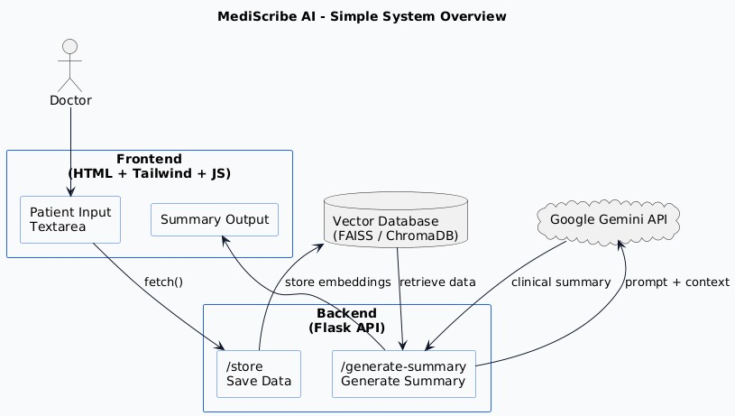
Figure 1: System Overview Diagram

2.System Design
The MediScribe AI system is designed using a scalable and modular layered architecture to ensure flexibility, maintainability, and production-readiness. The architecture is divided into four major layers: the Frontend Layer, Backend Layer, AI Services Layer, and Data Layer. Each layer has clearly defined responsibilities to maintain separation of concerns and simplify future enhancements.
The Frontend Layer is built using HTML and Tailwind CSS, providing a clean, distraction free healthcare interface. It includes a landing page, an about page, and a dedicated workspace where doctors input patient data. The design strictly follows a minimal clinical UI approach using a limited color palette for professionalism.
The Backend Layer is implemented using Python and Flask. It manages API routes such as storing patient data and generating summaries. This layer coordinates communication between the frontend, vector database, and LLM services.
The AI Services Layer handles embedding generation, vector storage, retrieval operations, and interaction with pluggable Large Language Models (OpenAI, Gemini, or Groq). The Data Layer uses a vector database (FAISS or ChromaDB) to store embeddings and enable similarity-based retrieval.The system follows a Retrieval-Augmented Generation (RAG) workflow, ensuring structured, context-aware, and accurate clinical summaries.

2.1 Application Design

The application design of MediScribe AI focuses on simplicity, professionalism, and efficiency, ensuring that healthcare professionals can use the system without distractions. The web application consists of three primary pages: the Landing Page, About Page, and Workspace Page. Each page is designed using HTML and Tailwind CSS, following a strict medical color scheme with a clean layout and minimal UI elements.
The Landing Page introduces the platform with a clear value proposition, highlighting its AI-powered healthcare documentation capabilities. It includes a professional navigation bar, a strong hero section with a call-to-action button, and a subtle auto-scrolling medical-themed visual section. The design ensures a modern SaaS-style healthcare interface without flashy effects.
The About Page explains the purpose of the application, the challenges of manual healthcare documentation, and how Generative AI improves efficiency and consistency. It presents information in clearly structured sections for readability.
The Workspace Page serves as the core functional interface, where doctors enter patient symptoms, medical reports, or observations. A large centered textarea with a circular send

button enables smooth interaction. The frontend communicates with Flask APIs to store patient data and generate structured clinical summaries, ensuring a seamless user experience.

2.2 Process Flow

The process flow of MediScribe AI follows a structured Retrieval-Augmented Generation (RAG) workflow to ensure contextual accuracy and professional medical output. The workflow begins when a healthcare professional enters raw patient data, such as symptoms, diagnostic findings, and clinical observations, into the workspace interface.
Once the input is submitted, the frontend sends a POST request to the backend’s /store API. The backend processes the text by converting it into vector embeddings using an embedding model. These embeddings are then stored securely in the vector database (FAISS or ChromaDB) along with relevant metadata.
When the user requests a clinical summary, a POST request is sent to the /generate-summary API. The backend retrieves relevant patient data from the vector database using similarity search techniques. The retrieved contextual information is then passed to the Large Language Model (LLM) along with a predefined system prompt and structured user prompt template.
The LLM generates a professional, structured clinical summary containing predefined headings such as Chief Complaints, Clinical Findings, Assessment, and Recommendations. The generated response is returned to the frontend and displayed to the user in a clear and readable format, completing the workflow efficiently and accurately.

Step-by-Step Process
- Doctor enters patient data
- POST /store API triggered
- Backend converts text to embeddings
- Embeddings stored in Vector DB
- POST /generate-summary API triggered
- Relevant data retrieved from Vector DB
- Retrieved data passed to LLM
- LLM generates structured output
- Response returned to frontend
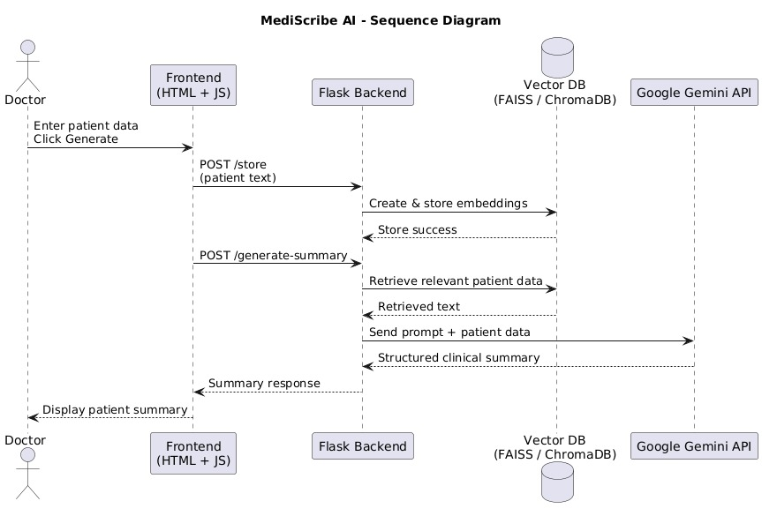
Figure 2: Process Flow

2.3 Information Flow

The information flow in MediScribe AI is designed to ensure structured processing, contextual accuracy, and secure handling of patient data. The flow begins at the Presentation Layer, where a healthcare professional inputs patient details such as symptoms, examination findings, and medical observations into the workspace interface. This input is transmitted securely to the backend through a REST API request.
Within the Application Layer, the Flask server receives the data and forwards it to the Vector Service. The raw text is converted into numerical embeddings using an embedding model. These embeddings are stored in the Vector Database along with associated metadata. This ensures that the information is indexed and can be retrieved efficiently using similarity-based search.
When a summary generation request is initiated, the backend retrieves the most relevant stored data from the Vector Database. The retrieved context is then passed to the LLM Service along with predefined system and user prompts. The LLM processes this structured input and generates a professional clinical summary in the required format.

Finally, the generated output is sent back to the frontend and displayed to the user. This layered information flow ensures separation of concerns, modularity, and adherence to the Retrieval-Augmented Generation architecture.

2.4 Components Design

The MediScribe AI system is divided into well-defined components to ensure modularity, scalability, and maintainability. Each component is designed with a clear responsibility, allowing independent development and easy future enhancements.
The Frontend Component is built using HTML and Tailwind CSS. It includes the landing page, about page, and workspace interface. This component handles user interaction, collects patient data, and communicates with backend APIs using HTTP requests.
The Backend Component is developed using Python and Flask. It manages API routes such as /store and /generate-summary, handles request validation, and coordinates communication between services. The backend acts as the central controller of the system.The LLM Service Component abstracts the integration with pluggable Large Language Model providers such as OpenAI, Gemini, or Groq. This modular design ensures that the LLM provider can be replaced without affecting other components.
The Vector Service Component is responsible for generating embeddings, storing them in the vector database (FAISS or ChromaDB), and retrieving relevant data using similarity search.Together, these components form a Retrieval-Augmented Generation architecture, ensuring structured, accurate, and professional clinical summary generation.

2.5 Key Design Considerations

The design of MediScribe AI is guided by several critical considerations to ensure reliability, professionalism, and scalability in healthcare documentation. One of the primary considerations is accuracy and contextual relevance. By implementing a Retrieval-Augmented Generation (RAG) architecture, the system ensures that the Large Language Model generates summaries based on retrieved patient data rather than raw, unstructured input alone.
Another key consideration is modularity and flexibility. The backend services are separated into LLM service, vector service, and prompt templates, allowing easy replacement of LLM providers (OpenAI, Gemini, Groq) or vector databases (FAISS, ChromaDB) without major architectural changes.

User experience and minimal design are also central to the system. The interface follows a strict medical color scheme with no gradients or flashy effects, ensuring a calm and professional clinical environment.
Security and data handling are important considerations, including proper API management, avoidance of hardcoded secrets, and controlled data flow between components. Additionally, the system is designed to be scalable and future-ready, supporting potential integration with secure cloud infrastructure and healthcare compliance standards.

2.6 API Catalogue

The MediScribe AI system exposes RESTful APIs to manage data storage and clinical summary generation. These APIs are designed to maintain a clean separation between the frontend interface and backend services, ensuring scalability and modularity.
The first API, POST /store, is responsible for accepting raw patient input from the workspace interface. The backend processes this input by converting it into embeddings and storing it in the vector database along with relevant metadata. The API returns a confirmation response indicating successful storage.
The second API, POST /generate-summary, retrieves relevant patient data from the vector database using similarity search. The retrieved context is then passed to the LLM service along with predefined prompt templates. The API returns a structured clinical summary containing sections such as Chief Complaints, Clinical Findings, Assessment, and Recommendations.
Note: The specific external LLM API provider (OpenAI, Gemini, Groq, etc.) has not been finalized at this stage. The system is intentionally designed with a pluggable architecture, allowing seamless integration of any suitable LLM API once selected. This ensures flexibility and future adaptability.

2.Data Design
The data design of MediScribe AI is structured to support a Retrieval-Augmented Generation (RAG) architecture while maintaining simplicity, scalability, and flexibility.
Since the primary objective of the system is to transform raw patient input into structured clinical summaries using contextual retrieval, the data model is centered around unstructured text storage combined with vector embeddings rather than traditional relational database structures.

The system primarily handles raw patient input data, which may include symptoms, examination findings, laboratory results, observations, and clinical notes. This input is treated as unstructured textual data. Instead of storing it in a conventional relational database with

predefined schemas, the system converts the input text into high-dimensional numerical embeddings using an embedding model. These embeddings capture the semantic meaning of the text, allowing similarity-based retrieval in later stages of the workflow.

The core storage mechanism is a Vector Database such as FAISS or ChromaDB. Each patient entry is stored along with its corresponding embedding vector and associated metadata. The metadata may include a unique identifier (UUID), timestamp of submission, and optional session information. This design ensures that each record is traceable while remaining lightweight and efficient. The vector database enables fast similarity search operations, which are essential for retrieving relevant context before passing information to the Large Language Model.

The data flow begins when raw patient text is submitted. The text is embedded and stored in the vector database. When a summary generation request is made, the system performs a
similarity search to retrieve the most relevant stored data. This retrieved context is then used to generate the final clinical summary. By ensuring that all data retrieval happens before LLM processing, the system maintains architectural integrity and avoids bypassing the vector database.
The design avoids storing sensitive structured medical data fields separately in this version to maintain simplicity and reduce schema complexity. However, the architecture is extensible and can integrate structured databases such as PostgreSQL or MongoDB in the future if detailed patient record management is required.

Overall, the data design prioritizes semantic retrieval, modularity, and scalability. It ensures that MediScribe AI remains efficient, adaptable, and aligned with modern AI-driven healthcare documentation systems while maintaining a clean and manageable data structure.

3.1 Data Model

The data model of MediScribe AI is designed to support semantic search and structured clinical summary generation using a vector-based storage approach. Unlike traditional relational systems that rely on predefined tables and rigid schemas, this system uses a vector database to store high-dimensional embeddings derived from raw patient text. This approach enables contextual retrieval based on meaning rather than exact keyword matching.
Each patient record consists of a unique identifier (UUID), the original raw text input provided by the healthcare professional, the generated embedding vector, and basic metadata such as timestamp. The raw text represents unstructured clinical information, including symptoms, examination findings, and observations. The embedding vector captures the semantic representation of this text and is stored within the vector database for similarity-based retrieval.

When a summary generation request is initiated, the system queries the vector database to retrieve the most relevant stored records based on similarity scores. The retrieved text is then passed to the LLM for structured output generation. This data model ensures flexibility, scalability, and efficient contextual retrieval while maintaining simplicity in implementation and future extensibility.
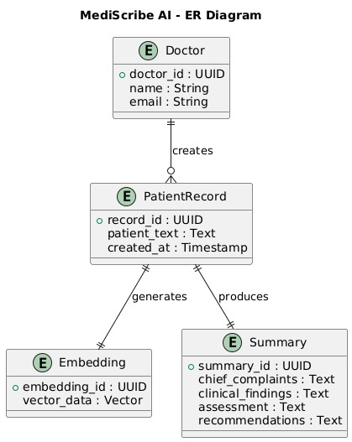
Figure 3: Data Model

3.2 Data Access Mechanism

The data access mechanism in MediScribe AI is designed around embedding-based retrieval rather than traditional query-based database access. Since the system uses a vector database (FAISS or ChromaDB), data retrieval is performed using similarity search instead of structured SQL queries. This approach enables semantic understanding and context-aware retrieval of patient information.

When a healthcare professional submits patient data, the backend converts the raw text into numerical embeddings using an embedding model. These embeddings are stored in the vector database along with associated metadata. Each stored record can be accessed using its unique identifier or through similarity-based search.
During summary generation, the backend generates an embedding for the new query or uses the most recent stored embedding. The vector database performs a similarity search (e.g., cosine similarity or Euclidean distance) to retrieve the most relevant patient records. The top-k most similar entries are selected and passed to the LLM service as contextual input.
This mechanism ensures efficient retrieval, reduced latency, and accurate context selection. It also supports scalability, as vector databases are optimized for high-dimensional data search and can handle growing volumes of medical records efficiently.

3.3 Data Retention Policies

The data retention policy of MediScribe AI is designed with flexibility, security, and scalability in mind. Since the system primarily stores raw patient text and its corresponding embeddings in a vector database, retention is managed at the vector storage level rather than through complex relational database mechanisms.
In the current implementation, patient records are stored locally within the designated vector database directory. Each record contains the raw input text, embedding vector, and basic metadata such as a unique identifier and timestamp. Data is retained for the duration required to support contextual retrieval and summary generation. However, the system architecture allows configurable retention rules to be implemented in future versions.
Retention policies may include automatic deletion after a predefined time period, manual deletion by administrators, or periodic cleanup of outdated records. Since healthcare data is sensitive, long-term storage should comply with applicable data protection regulations and institutional policies.
The modular design ensures that retention rules can be enforced at the vector service layer without affecting other components. This approach provides adaptability for future integration with secure cloud storage solutions or healthcare-compliant infrastructures, ensuring responsible handling of patient-related information.

3.4 Data Migration

The data migration strategy of MediScribe AI is designed to ensure flexibility and future scalability without disrupting system functionality. Since the application stores patient data as

embeddings within a vector database (FAISS or ChromaDB), migration primarily involves transferring embedding vectors, raw text data, and associated metadata to another storage system or infrastructure.
In the current implementation, embeddings are stored locally within the project directory. For migration purposes, stored vectors and metadata can be exported in serialized formats such as JSON or binary index files, depending on the vector database being used. These exported files can then be imported into another vector database instance or cloud-based storage system.
The architecture also supports switching between vector databases, such as migrating from FAISS to ChromaDB, by abstracting database operations within the vector service module. Similarly, changing the LLM provider does not affect stored embeddings, ensuring independence between AI services and data storage.
This modular approach minimizes downtime and reduces the risk of data loss during migration. It ensures that MediScribe AI can evolve with technological advancements, infrastructure upgrades, or compliance requirements while maintaining data integrity and operational continuity.

4. Interfaces
4.1 User Interface (Web Frontend)
The User Interface of MediScribe AI is a web-based frontend built using HTML and Tailwind CSS. It serves as the primary interaction point for healthcare professionals. The interface consists of a landing page, an about page, and a workspace page. The workspace provides a large, focused textarea where doctors can input patient symptoms, reports, and observations. A circular primary-action button allows users to submit data for storage and summary generation. The UI follows a strict medical color scheme with minimal design elements to maintain a calm and professional clinical environment. It avoids distractions such as gradients or flashy effects, ensuring that the focus remains on medical documentation. The frontend communicates with the backend using REST APIs and handles response rendering in a structured format.

4.2 Backend API Interface
The Backend API Interface is implemented using Python and Flask. It exposes RESTful endpoints that allow communication between the frontend and backend services. The primary APIs include /store for storing patient input in the vector database and /generate-summary for generating structured clinical summaries. These APIs accept and return data in JSON format, ensuring standardized communication. The backend acts as a mediator between the user interface, vector database, and LLM service. It handles request validation, data processing,

embedding generation, and response formatting. The modular API design ensures scalability and maintainability. Additionally, the abstraction of LLM and vector services ensures that changes in AI providers or storage mechanisms do not require major modifications to the API structure.

4.3 LLM Service Interface
The LLM Service Interface is responsible for interacting with the selected Large Language Model provider, such as OpenAI, Gemini, or Groq. This interface is abstracted within the llm_service.py module, ensuring that the application remains provider-agnostic. It receives structured prompts from the backend, including a system prompt and a user prompt template containing retrieved patient data. The service sends these prompts to the chosen LLM API and processes the generated response. By isolating LLM communication in a dedicated service layer, the system allows easy replacement or upgrading of AI providers without affecting other components. This design ensures flexibility, maintainability, and compliance with the project requirement of a pluggable LLM architecture.

4.4 Vector Database Interface
The Vector Database Interface manages embedding storage and retrieval operations. Implemented within the vector_service.py module, it handles the conversion of raw patient text into embeddings and stores them in FAISS or ChromaDB. During summary generation, this interface performs similarity-based searches to retrieve relevant stored records. The interface abstracts database-specific operations, ensuring that switching between vector database technologies requires minimal changes. It supports efficient indexing, fast similarity search, and scalable data management. By acting as an independent service layer, the vector database interface ensures that the system adheres to the Retrieval-Augmented Generation workflow and maintains contextual integrity in summary generation.

5. State and Session Management
State and session management in MediScribe AI is designed to be lightweight, secure, and scalable, following modern web application best practices. Since the system is built using Flask as a backend framework and follows a RESTful architecture, it primarily operates as a stateless application. This means that each API request from the client contains all the necessary information required to process that request, and the server does not rely heavily on persistent session storage to maintain user state.
In the current implementation, MediScribe AI does not require complex user authentication or long-lived user sessions. The primary workflow involves accepting patient input, storing it in a vector database, retrieving relevant information, and generating a clinical summary. Each

of these actions is handled through independent API calls. The backend processes each request separately, which improves scalability and reduces server-side memory usage.
Although the backend is stateless, minimal state handling may occur at the frontend level. For example, the workspace interface may temporarily hold the latest patient input or generated summary within the browser session. This ensures smooth user interaction without requiring persistent server-side session tracking. Since the application is designed to minimize distractions and maintain a clean clinical interface, session handling remains simple and unobtrusive.
If future versions introduce authentication mechanisms (such as login systems for doctors or hospitals), session management can be implemented using secure token-based authentication, such as JWT (JSON Web Tokens). In such a scenario, tokens would be stored securely on the client side and validated on each API request. This approach would maintain statelessness while ensuring secure access control.
From a data perspective, patient inputs are stored in the vector database along with metadata such as timestamps and unique identifiers. This metadata acts as a logical state reference for stored records rather than relying on traditional session objects. When a summary generation request is made, the backend retrieves relevant records based on embeddings rather than user session variables.
Security is also enhanced through limited session dependency. By avoiding extensive server-side session storage, the risk of session hijacking or session fixation attacks is reduced. Additionally, environment variables are recommended for storing sensitive API keys, further strengthening security practices.
Overall, the state and session management approach in MediScribe AI emphasizes simplicity, scalability, and security. The system remains primarily stateless, uses metadata for contextual reference, and can easily integrate secure token-based authentication in future enhancements without architectural disruption.

6. Caching
Caching in MediScribe AI is an important design consideration aimed at improving performance, reducing response latency, and minimizing repeated computational overhead, especially when interacting with Large Language Models (LLMs) and vector databases. Since AI model calls and embedding generation can be resource-intensive and time-consuming, implementing an efficient caching strategy can significantly enhance system responsiveness.
In the current architecture, the system follows a Retrieval-Augmented Generation (RAG) workflow. When a doctor submits patient data, embeddings are generated and stored in the vector database. During summary generation, relevant data is retrieved and passed to the LLM for processing. If similar or identical inputs are processed multiple times, repeated

embedding generation and LLM calls may result in unnecessary delays and increased API costs. Caching mechanisms can help prevent redundant computations.
One potential caching layer can be implemented at the LLM response level. If a previously processed patient input produces a summary, the system can store the generated summary along with a hash of the input text. When the same input is submitted again, the system can return the cached summary instead of calling the LLM again. This reduces API usage, lowers operational cost, and improves performance.
For scalable deployments, external caching systems such as Redis can be integrated. Redis can act as a high-speed in-memory cache to store embeddings, similarity results, or LLM outputs. This would be particularly beneficial in high-traffic healthcare environments where multiple summary requests are processed concurrently.
Frontend-level caching can also be applied temporarily within the browser session. For example, recently generated summaries can remain available without triggering new backend requests unless the input changes. This improves user experience without affecting backend resources.
However, caching in healthcare systems must be handled carefully due to the sensitivity of patient data. Cached data should be securely stored, encrypted if necessary, and cleared according to defined data retention policies. Long-term caching of sensitive medical information should comply with data protection regulations.
Overall, the caching strategy in MediScribe AI is designed to optimize performance while maintaining security and compliance. The modular backend architecture allows easy integration of advanced caching solutions in the future without major structural changes.

7. Non-Functional Requirements
The non-functional requirements of MediScribe AI define the quality attributes that ensure the system performs reliably, securely, and efficiently in real-world healthcare environments. One of the primary requirements is scalability. The system must support increasing volumes of patient data and concurrent users without significant performance degradation. The stateless backend design and modular service architecture enable horizontal scaling when deployed in cloud environments.
Performance is another critical requirement. The system should generate clinical summaries within an acceptable response time, even when processing embedding generation and LLM requests. Efficient vector search mechanisms and optional caching strategies contribute to performance optimization.
Reliability and availability are essential, as healthcare documentation systems must function consistently without unexpected failures. The modular architecture ensures that individual components can be maintained or upgraded without affecting the entire system. Maintainability and extensibility are also key requirements. The pluggable LLM service and

vector database abstraction allow easy integration of new technologies in the future. Finally, usability is prioritized through a clean, distraction-free interface that promotes a professional clinical workflow and enhances user experience for healthcare professionals.

7.1 Security Aspects
Security is a critical consideration in MediScribe AI, especially since the system handles sensitive patient-related information. Although the current implementation is a prototype-level healthcare documentation assistant, the architecture is designed with secure practices in mind. All communication between the frontend and backend APIs should occur over secure HTTPS connections to prevent data interception during transmission.
Sensitive credentials such as LLM API keys are not hardcoded in the source code. Instead, they are stored securely using environment variables through the configuration file. This reduces the risk of credential exposure in version control systems. Input validation is also implemented at the backend level to prevent malicious or malformed data from affecting system stability.
The system follows a stateless design, reducing risks related to session hijacking or session fixation attacks. Since data is stored in a vector database, access control mechanisms can be implemented to restrict unauthorized data retrieval.
Future enhancements may include authentication mechanisms, role-based access control, encryption of stored data, and compliance with healthcare data protection standards to ensure stronger security and privacy safeguards.

7.2 Performance Aspects
Performance is a key consideration in the design of MediScribe AI, as healthcare professionals require quick and reliable generation of clinical summaries. The system is optimized to minimize latency during embedding generation, vector retrieval, and LLM response processing. By using a lightweight backend framework such as Flask, the application ensures fast request handling and reduced server overhead.
The use of a vector database like FAISS or ChromaDB enables efficient similarity search operations even as the volume of stored patient data increases. Vector indexing mechanisms allow rapid retrieval of the most relevant records, which reduces the time required before sending contextual data to the LLM.
To further enhance performance, optional caching mechanisms can be implemented for repeated inputs or frequently accessed summaries. This reduces redundant LLM API calls and lowers response time. The stateless backend architecture also supports horizontal scaling,

allowing multiple server instances to handle concurrent requests.Overall, the performance design ensures that MediScribe AI delivers timely, accurate, and consistent results suitable for real-time healthcare documentation workflows.

8. References
1. OpenAI. (2023). GPT-4 Technical Report. OpenAI Research. Available at: https://openai.com/research
2. Lewis, P., Perez, E., Piktus, A., et al. (2020). Retrieval-Augmented Generation for Knowledge-Intensive NLP Tasks. Advances in Neural Information Processing Systems (NeurIPS 2020).
3. Johnson, J., Douze, M., & Jégou, H. (2017). Billion-scale similarity search with GPUs. IEEE Transactions on Big Data. (FAISS Library).
4. ChromaDB. (2023). Chroma: The AI-native Open-Source Embedding Database. Official Documentation.
5. Grinberg, M. (2018). Flask Web Development: Developing Web Applications with Python. O’Reilly Media.
6. Vaswani, A., Shazeer, N., Parmar, N., et al. (2017). Attention Is All You Need. Advances in Neural Information Processing Systems (NeurIPS 2017).
7. Rajkomar, A., Dean, J., & Kohane, I. (2019). Machine Learning in Medicine. New England Journal of Medicine, 380(14), 1347–1358.
8. Shortliffe, E. H., & Cimino, J. J. (2014). Biomedical Informatics: Computer Applications in Health Care and Biomedicine. Springer.

